Software Requirements Specification

For

Practo (Find Doctors, Clinics & more)
Version 1.0

By
RJT

Table of Contents
Table of Contents ii

1. Introduction 1
1.1 Purpose 1
1.2 Project Scope 1

2. Overall Description 2
2.1 User Characteristics 2
2.2 Constraints 2

3. Use Case Diagram 4

4. Database Design 5

5. Activity Diagarm 6

6. Sequence Diagram 12

7. UI / Screen Designs 17

Introduction

Purpose
The main objective of this project is to implement a web application which helps patients to find doctors online and schedule appointment. Practo Healthcare System is a web application is to make hospital task easy and is to develop software that replaces the manual hospital system into automated hospital management system.

Project Scope
- There are three basic users in the system - Patient, Admin, Doctors.
- All users have their own profiles in PHS system.

Overall Description

User Characteristics:
Users of the system:

- Patients
- Doctors
- Administrator

Patient:
- Patients can search for doctor and make online appointments. They also can view and edit their profile, search for a doctor and make appointment as well view their booking history.
Doctor:
- Doctors can create their own schedule depending on their availability, edit their profile and look at the appointments they have, and request leave to admin.
Admin:
- Admin has the authority to add/delete doctors, view all appointments made in the system and approve doctor’s leave.

Constraints
- GUI is only in English.

- Login and password is used for identification of user and there is no facility for guest.

Use Case Diagram

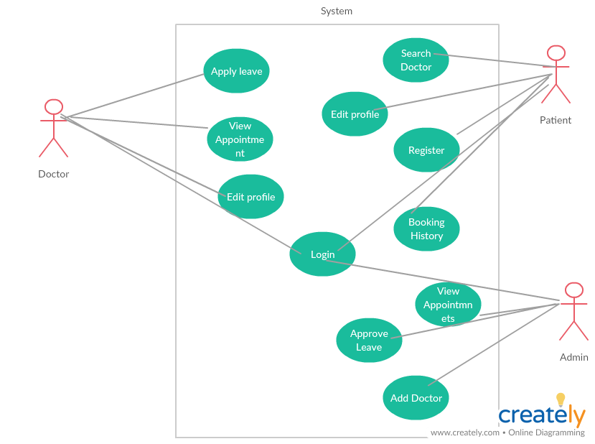

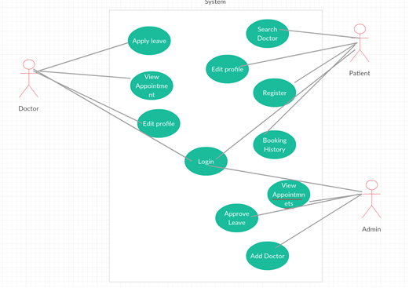

Class Diagrams

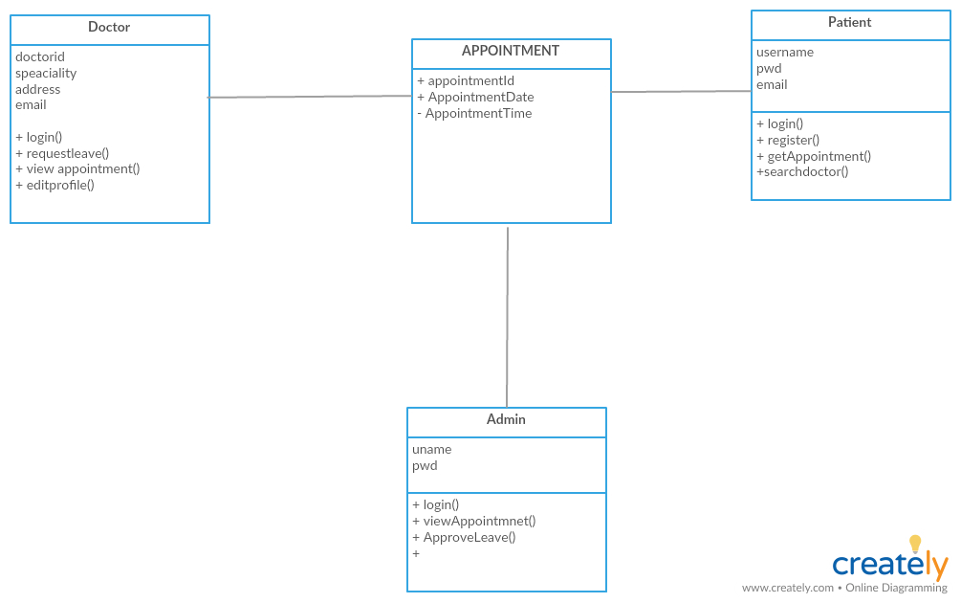

Activity Diagrams

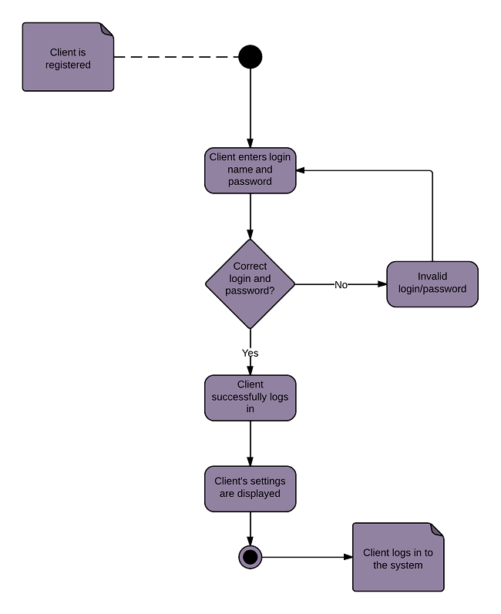

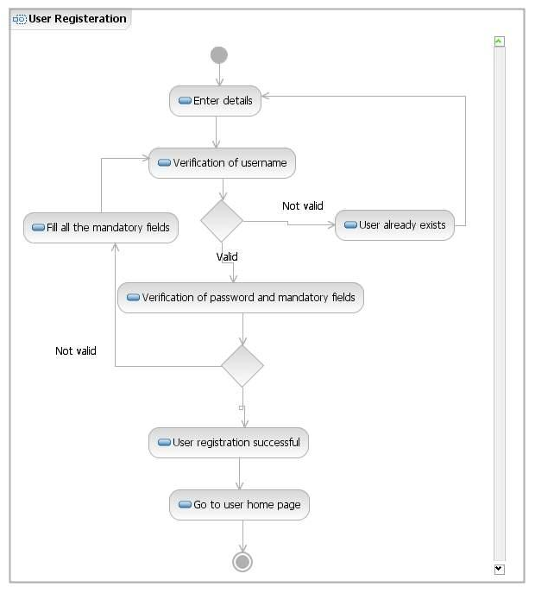

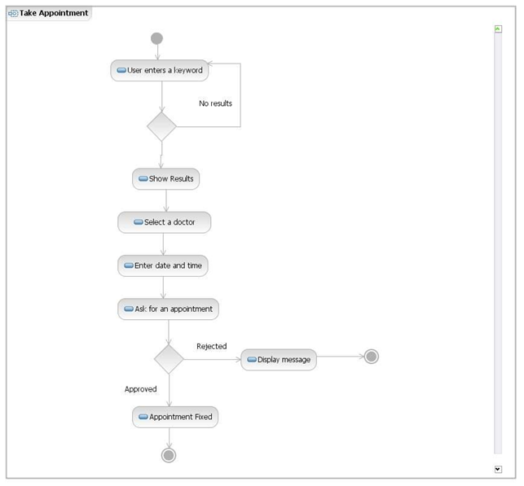

Sequence Diagrams

Users Log-in Sequence Diagram

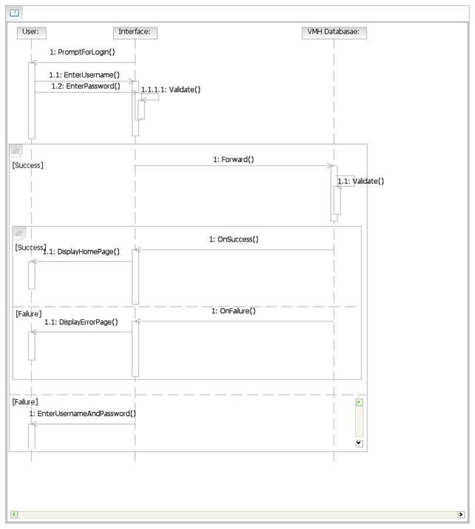

Make an Appointment Sequence Diagram

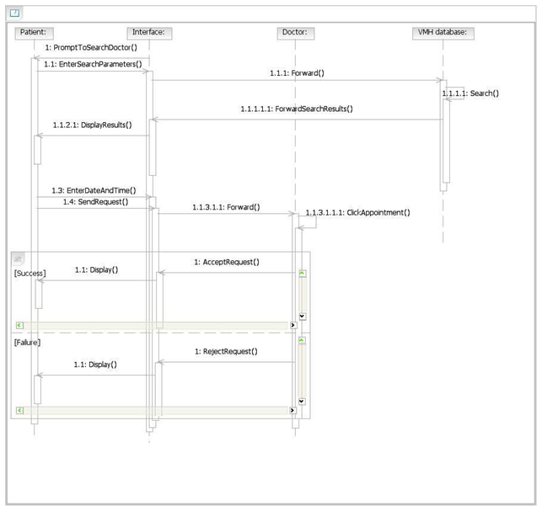

Authentication of Privileged Users Sequence Diagram

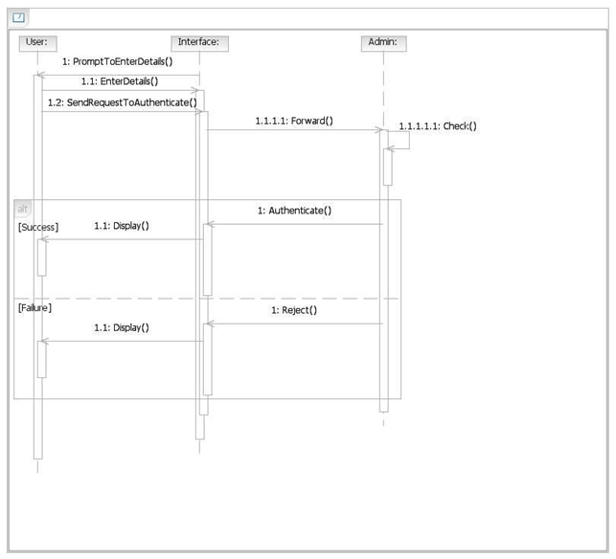

Make Appointment

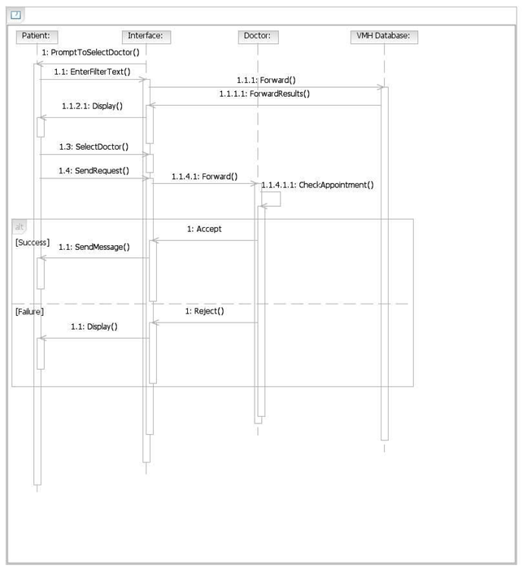

UI Design

Login

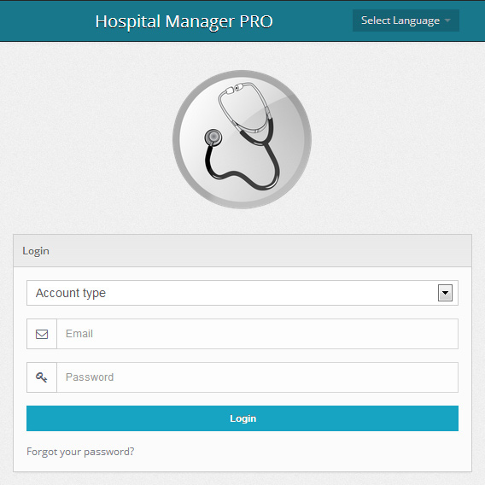

Patient Registration Screen

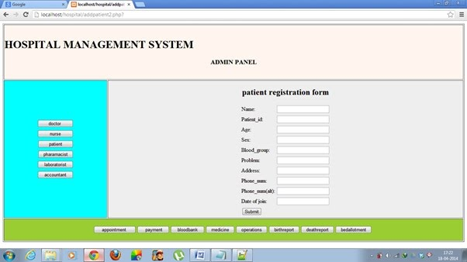

Search Doctor

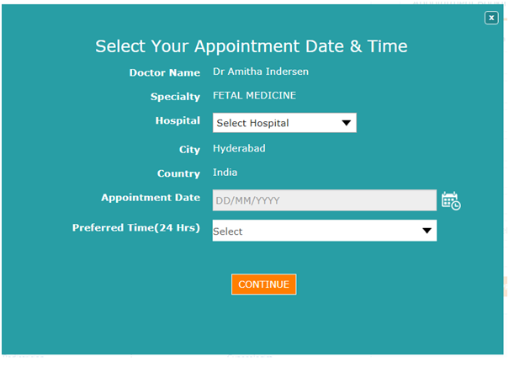
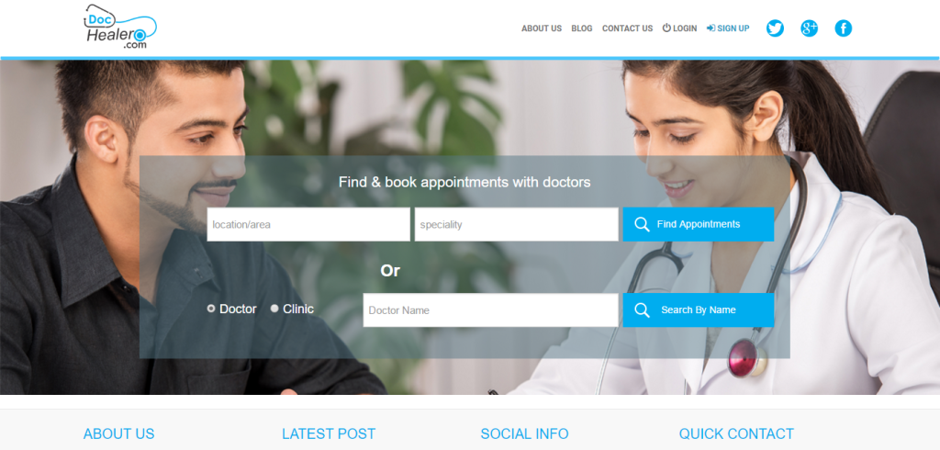

Schedule Appointment

Edit Profile

